How to import and run searches in TPP
EARLY Identification Tool v1.2s
January 2023

Change log:
V1.1 January 2023 – change log added and footer updated
v1.0 June 2022 Guide created

You will receive these searches by email either in a zip folder or XML file (please see instructions on how to save from an email)

Please note the screenshots are examples only. The title of Early Identification Tool v1.2s will be what you receive.

When receiving the searches by email in a zip folder

Download the zip folder you have been sent and Save it onto your desktop (or somewhere you can access)

Example
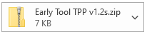

To save the attachment: In your email go to the Attachment tab on the top ribbon

Select Save all attachments

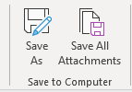

Click OK

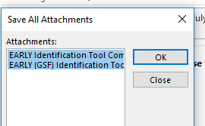

Now choose where you would like to save the zip folder (on your desktop, where it’s easy to retrieve)
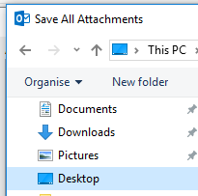

You have now saved the zip folder on your desk top. Please follow the next steps to unzip

The zip denotes the contents of the folder needs extracting

Right Click the folder and choose Extract All

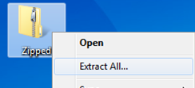

Choose extract

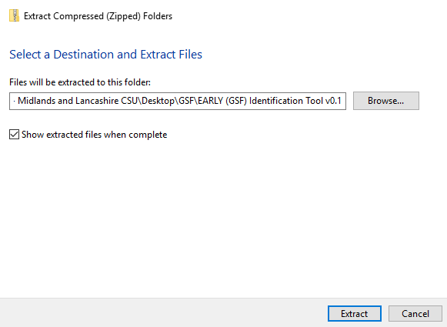

You have now extracted the files from the zip folder into the folder listed above.

You have now saved your search file ready to import into TPP

When receiving the searches by email in rtf format

Download the rtf file you have been sent and Save it onto your desktop (or somewhere you can access)

Example
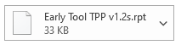
Right click on attachment and select save as

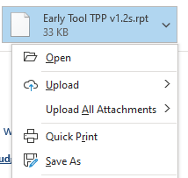

Choose where you would like to save this (on your desktop, where it’s easy to retrieve)

You have now saved your search file ready to import into TPP

How to import a search into SystmOne TPP

Deleting and Importing Searches into SystmOne

Go into Clinical Reporting: To do this click Reporting from the drop-down menu and then select Clinical Reporting

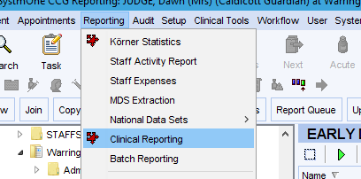

Go to local reports and select the folder of your Early detection reports, select the folder EARLY Detection and ensure the tick in show sub-category reports in category folders is ticked
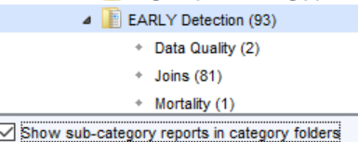
Now delete the reports in this folder.
Click on the folder where you want the folder to be saved and click import you will now see the bar below
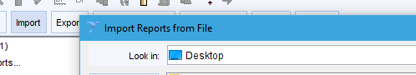

Select the file you wish to import

Navigate where you saved the search from the email (see relevant previous section), highlight and click select. Note: This will be a rpt document.

You will then receive an information notice to say that you have successfully read 93 reports into TPP

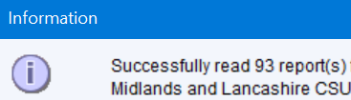

You will then receive an import reports section, select Keep Existing Categories at the bottom of the screen and click ok

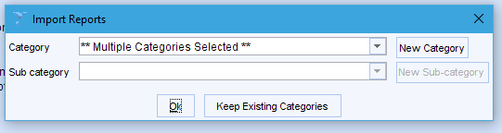

You will now have a folder as shown below in local reports
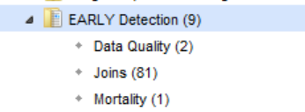

The searches will now be in your system and ready to run.

Running searches in TPP
You need to run the searches to obtain the search results. You can run a search immediately after you import.
Navigate to and select the required search you just imported EARLY Detection. Click on the folder of the search.
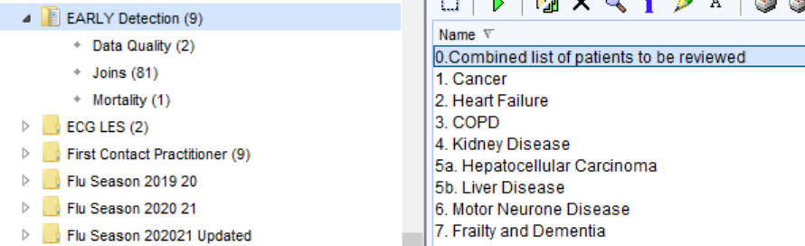

Click on the 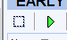 and all of the reports will be highlighted then click the green run icon this will run all the searches together.
When viewing search results, you will need to re-run the search to update the results so you are working with the latest results.
You can view the search results by 0,Combined list of patients to be reviewed, shows all patients with any of the conditions indicated in report 1-7. You can also search on the specific number to look at individual areas.

Data Quality Folder:
Within the data quality folder there are 2 searches with reports.
PAL2. This gives you the patients that have been seen by Palliative Care Service in L2m but are not on your QOF Palliative care register
PAL3. This gives you patents on the QOF register but they have no GSF stage recorded
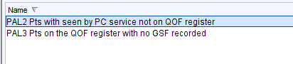
The Data Quality searches are there to help you identify patients that may have miscoding or may have something missing on their record.

Mortality Audit:
This search looks at patients who have died in the last 12 months.
This search can help the practice to review those patients who have died over the last 12 months. Viewing the report indicates if they were already on the palliative care register, had an EPaCCS record, their preferred place of care/death recorded and carer/next of kin details.
Warning: Be aware of Information Governance standards before sharing files.
This guide has been written by the Data Quality Team Lancashire to help practices understand the tools created to assist with the EARLY Identification Tool v1.2s. If you believe items are inaccurate or something is missing from the content, please contact your data quality contact within your area.

