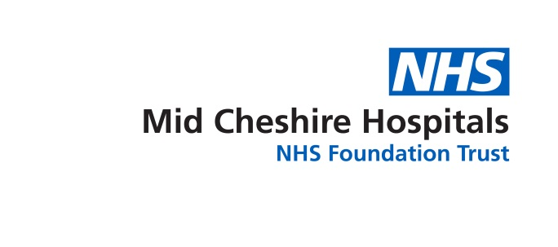
Important information for patients
The team involved in the care and treatment of people with lung cancer
Revised and reprinted June 2017 Review June 2019 www.mchft.nhs.uk We care because you matter
Ref: SC/MLCNS/0030617
Author: Sue Stubbs

This leaflet is available in audio, Braille, large print and other languages. To request a copy, please telephone 01270 612598.

6

Please use the space below to write down any questions you might want to ask your doctor or the Macmillan Clinical Nurse Specialist and bring this leaflet with you to your next appointment:
……………………………………………….
……………………………………………….
……………………………………………….
……………………………………………….
……………………………………………….
……………………………………………….
……………………………………………….
……………………………………………….
……………………………………………….
……………………………………………….
……………………………………………….
……………………………………………….
……………………………………………….
……………………………………………….
……………………………………………….
……………………………………………….
……………………………………………….
……………………………………………….
……………………………………………….
……………………………………………….

Useful Contact Details

Macmillan Lung Cancer Clinical Nurse Specialists
Leighton Hospital
Telephone number: 01270 612598
Email address: macmillanlungcancerteam@mcht.nhs.uk

Macmillan Cancer Support Service, Leighton Hospital
Telephone number: 01270 273603

Macmillan Cancer Support
Telephone number: 0808 808 00 00 or visit www.macmillan.org.uk

Roy Castle Lung Foundation
Telephone number: 0333 323 7200 or visit www.roycastle.org

Your diagnosis and treatment plan
Your diagnosis: ……………………………………

Your treatment plan: ………………………………..
……………………………………………….
……………………………………………….
……………………………………………….……………………………………………….……………………………………………….……………………………………………….
……………………………………………….
……………………………………………….
……………………………………………….
5
This leaflet is to help you to understand the role of different professionals involved in your treatment and care if you have lung cancer. It will also help you to understand how your treatment is decided.

The Lung Cancer Multi-Disciplinary Team (MDT)

Diagnosing and treating lung cancer requires a team of experts with different skills and training. This team is called a Multi-Disciplinary Team (or MDT for short). It includes professionals who are specialists in different aspects of cancer care, including diagnosis, treatment and helping you to cope with the effects of the illness.

The team includes:

Macmillan Lung Cancer Clinical Nurse Specialists

Nurses who are expert in the care and support of people with lung cancer.
The Macmillan Lung Cancer Clinical Nurse Specialist can:
- Provide support, information and advice through all stages of your illness
- Liaise between all members of the team, you and your family,
your GP and community staff
- Help you to manage difficult symptoms.

Consultant Chest Physicians

A specialist doctor who is involved in the early stages when problems are first noted.
The Chest Physician can:
- Order tests to help confirm diagnosis
- Carry out investigations such as bronchoscopy (looking into the lungs through a special tube with a small camera), and take biopsies (tissue samples) of the lung
- Help with other lung problems you may have during your illness.
2

Consultant Chest Physicians

A doctor who specialises in chest surgery.
The Thoracic Surgeon can:
- Help with diagnosis and take lung biopsies from hard to reach areas
- Carry out tests on your lungs
- Explain any surgery you need
- Carry out surgery to remove your lung cancer, if necessary.

Consultant Radiologist

A doctor who is an expert in performing and interpreting x-rays and special scans, for example, Computerised Tomography (CT) and Magnetic Resonance Imaging (MRI) scans. The Consultant Radiologist can also advise the team about which tests you should have.

Consultant Histopathologist

A doctor who is an expert in looking at tissue samples under a microscope to see if cancer cells are present, and if so the type of cancer. This helps us to work out how the cancer cells might behave, which is very important in deciding on the best treatment.

Consultant Oncologist

A specialist doctor who is an expert in non-surgical treatments for cancer. Clinical Oncologists specialise in radiotherapy but may also have expertise in chemotherapy (drug treatment). Medical Oncologists specialise in chemotherapy. The Oncologist advises the team about the non-surgical treatments you could have.

Palliative Care Specialist

A doctor who is specially trained to help you and your family achieve the best quality of life. This is called palliative care and includes managing your symptoms and giving emotional support.
3

How your treatment is decided

To make sure you are given the most appropriate treatment for you, your case will be discussed at an MDT meeting attended by all members of the team. The MDT meetings are held weekly on a Tuesday. At the meeting the team will discuss all the options for your treatment. Afterwards these will be explained to you either at a clinic appointment or by telephone/letter and you will be offered further written information to help you make a decision about your treatment. You will be able to ask any questions you have, and we will give you as much information as you would like.

If you need radiotherapy treatment this will be given at The Christie Hospital in Manchester. The doctors who work at The Christie hold clinics at Leighton Hospital to discuss treatment and to follow patients up after your treatment. You will be given more information about the treatment you decide to have and where this will take place.

Any Questions?

If you have any questions, worries, or do not understand something you have been told, your Clinical Nurse Specialist can help. The nurses are available 8.00 am – 4.00 pm Monday to Friday on 01270 612598. If the nurse is not available, please leave a message on the telephone answering machine with your name and telephone number. All messages will be responded to as quickly as possible, although this may not always be the same day.

If you have an urgent medical problem you should ring your GP surgery. If the surgery is closed there will be an answer phone message telling you who you should get in touch with.

If you are a patient receiving chemotherapy please ring your 24 hour chemotherapy hotline number which can be found in the back of your red book.

4

