

**Further Information**

**Customer Care Team**

To make comments or raise concerns about the Trust’s services, please telephone 01270 612410.

**NHS choices**

Provides online information and guidance on all aspects of health and healthcare, to help you make choices about your health.  
www.nhs.uk

**Arthritis Research UK**

Provides online information and guidance on managing musculoskeletal conditions.

www.arthritisresearchuk.org

**Our locations for Musculoskeletal Specialist Assessment & Triage Service**

* Ashfields Primary Care Centre, Sandbach
* Alsager Health Centre
* Barnton Clinic, Northwich
* Eaglebridge Health and Wellbeing Centre, Crewe
* Wharton Primary Care Centre, Winsford

**Contact us**

If you have any questions or concerns about an appointment or treatment, please telephone:

01270 278310 Monday to Friday, 9.00am to 4.30pm

Musculoskeletal Single Point of Access Service

**Liz Robinson B**

Information for patients



This leaflet is available in audio, Braille, large print and other languages. To request a copy, please telephone 01270 278310.



**Reprinted April 2018 Review April 2020 Ref: CCICP/PHYSIO/0090418** [**www.mchft.nhs.uk**](http://www.mchft.nhs.uk) **We care because you matter**

##### Printed December 2015 Review December 2017 Ref: WCSH/CAU/0201215

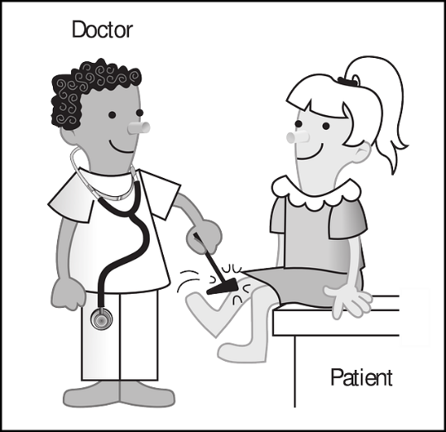

**How are patients referred to the service?**

Any registered GP within South Cheshire and Vale Royal can refer patients to the service.

**What happens when a referral is received?**

Referrals will be reviewed by an Advanced Musculoskeletal Practitioner to ensure you are seen in the right clinic and provided with the most appropriate treatment from the beginning. Following this you will be contacted to arrange one of the following:

* Face to face assessment and management by a physiotherapist
* Face to face appointment with an Advanced Musculoskeletal Practitioner or GP with special interest
* Referral to hospital to see an

Orthopaedic/ Rheumatology Consultant or Musculoskeletal Pain service

**What will happen at the Musculoskeletal Specialist Assessment & Triage Service clinic appointment?**

* A specialist assessment will be carried out
* Wear comfortable clothing as you might be required to carry out a number of movements or undress for examination
* Appointments can last 30-40 minutes
* Further tests may be arranged  
  e.g. X-rays, scans, bloods

After your assessment you will be offered advice and treatment. This may include physiotherapy, injection or referral to a hospital Consultant.

If you are referred to a Consultant, you will be offered the choice of which hospital you would like to be seen.

**What is Central Cheshire Integrated Care Partnership Musculoskeletal Single Point of Access Service?**

It is a one-stop service for people experiencing musculoskeletal problems. This may include problems with joints, muscles and other soft tissues e.g. ligaments and nerves.

**What are the advantages?**

* Single point of access for all musculoskeletal referrals including physiotherapy, musculoskeletal specialist assessment and triage service, orthopaedics, rheumatology and musculoskeletal pain services
* Fast access to the right assessment, tests and treatment
* Seamless transfer to hospital Consultants

**www.mcht.nhs.uk**

Patient Experience Team

www.mcht.nhs.uk