How to copy & paste searches from Enterprise Search & Reports (ESR) and run searches in EMIS Web
EARLY Identification Tool v1.0
June 2020

How to copy searches from ESR
In EMIS go to ‘Population Reporting’
At the bottom left of the screen (above QOF) click on the folder (depending on your area) there will be a CCG folder (example as below)
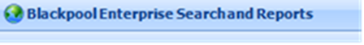
Go into Distributed folder 2020-21
Highlight folder:
Right click on yellow folder icon and select copy
Click back into your own practice folder, right click in the folder you would like to save the searches and paste.
Please always copy and paste your searches form ESR back into your practice folder in EMIS, do not run within ESR.
Running searches in EMIS
You need to run the searches to obtain the search results. You can run a search immediately after you import.
Navigate to and select the required search you just downloaded. Click on the folder of the search. If you click on the name of the folder this will then run all the searches within the folder
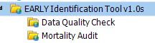

Click Run on the blue ribbon at the top of the page
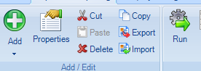
When viewing search results, ensure that the search has been run recently so that you are working with the latest results.
You can view the search results by individual folders or looking at the Combined List of Patients to be reviewed Report
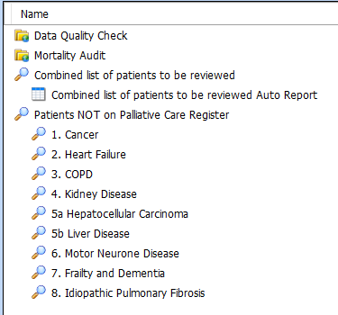
To view click once on the required report
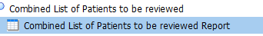
Select View Results on the ribbon.
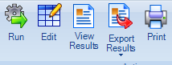

Note: The Export Results ribbon option is designed for exporting searches. It only allows you to export the report details, not the data. For this reason, you need to view a report before you can export it.
You can view the report on EMIS, or you can export the results
On the Report Viewer ribbon, select Export.
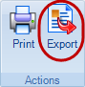

On the Export Report screen, choose from the following options:
Select a report format:
    - Excel
    - CSV
    - HTML
    - PDF
Tick the Exclude report header option, if you want to exclude the report header.
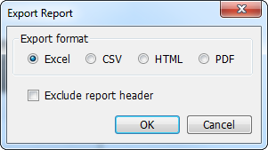
Click OK to export your report.
On the Save As screen, navigate to the folder you want to save your file in, and then click Save.
The data is saved in your chosen format

To view a Patient list and not a report:
Click on Combined list of patients to be reviewed
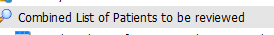
Navigate to the tabs at the bottom and choose population included
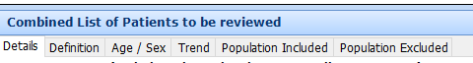
This will give you a list of all the patients from each search

Data Quality Folder:
Within the data quality folder there are 2 searches with reports.
PAL2. This gives you the patients that have been seen by Palliative Care Service in L2m but are not on your QOF Palliative care register
PAL3. This gives you patents on the QOF register but they have no GSF stage recorded
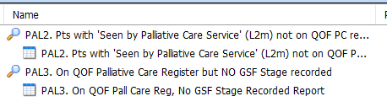
The Data Quality searches are there to help you identify patients that may have miscoding or may have something missing on their record.
Mortality Audit:
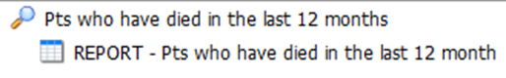
This search can help the practice to review those patients who have died over the last 12 months. Viewing the report indicates if they were already on the palliative care register, had an EPaCCS record, their preferred place of care/death recorded and carer/next of kin details.
Warning: Be aware of Information Governance standards before sharing files.
This guide has been written by the Data Quality Team Lancashire to help practices understand the tools created to assist with the EARLY Identification Tool v1.0. If you believe items are inaccurate or something is missing from the content, please contact your data quality contact within your area.

