How to import and run searches in EMIS Web
EARLY Identification Tool v1.0
August 2019

You will receive these searches by email either in a zip folder or XML file (please see instructions on how to save from an email)

Please note the screenshots are examples only. The title of Early Identification Tool v1.0 will be what you receive.

When receiving the searches by email in a zip folder

Download the zip folder you have been sent and Save it onto your desktop (or somewhere you can access)

Example
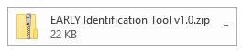

To save the attachment: In your email go to the Attachment tab on the top ribbon

Select Save all attachments

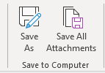

Click OK

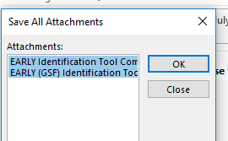

Now choose where you would like to save the zip folder (on your desktop, where it’s easy to retrieve)
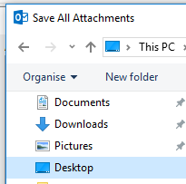

You have now saved the zip folder on your desk top. Please follow the next steps to unzip

The zip denotes the contents of the folder needs extracting

Right Click the folder and choose Extract All

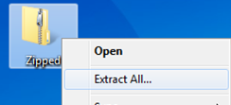

Choose extract

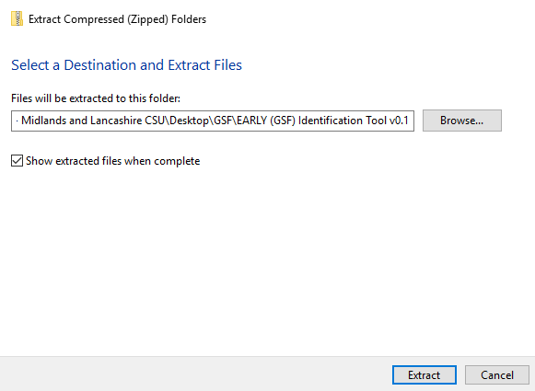

You have now extracted the files from the zip folder into the folder listed above.

You have now saved your search file ready to import into EMIS Web

When receiving the searches by email in xml format

Download the xml file you have been sent and Save it onto your desktop (or somewhere you can access)

Example
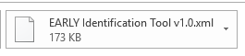
Right click on attachment and select save as

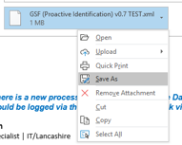

Choose where you would like to save this (on your desktop, where it’s easy to retrieve)

You have now saved your search file ready to import into EMIS Web

How to import a search into EMIS Web

Importing Searches into EMIS Web

Go into Population reporting in EMIS: To do this click the EMIS ball, select Reporting from the drop-down menu and then select Population Reporting

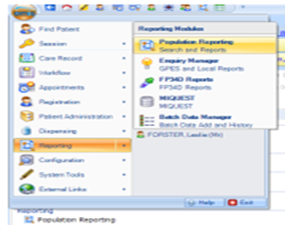

Go to your practice folder in Population Reporting, highlight where you want the folder to be saved and click import which you’ll find on the top left-hand side of the blue ribbon

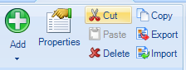

Click on the three dots next to Enquiry Document
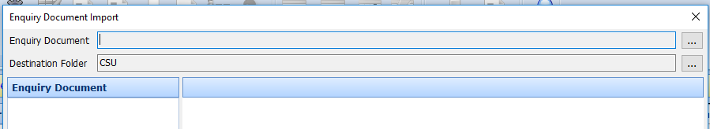

Navigate where you saved the search from the email (see relevant previous section), highlight and click open. Note: This will be an XML document

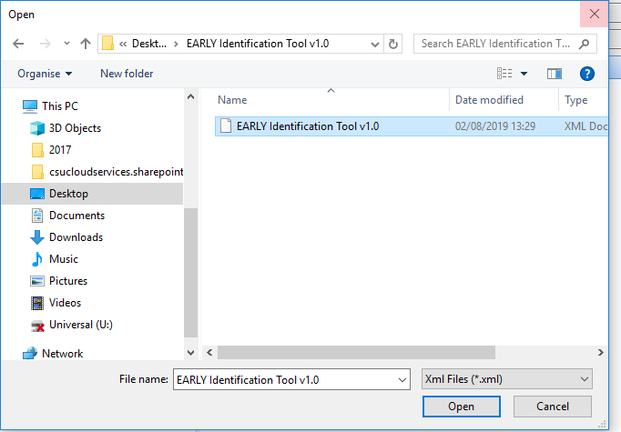

The searches that the folder will bring through will be visible in the left-hand pane.

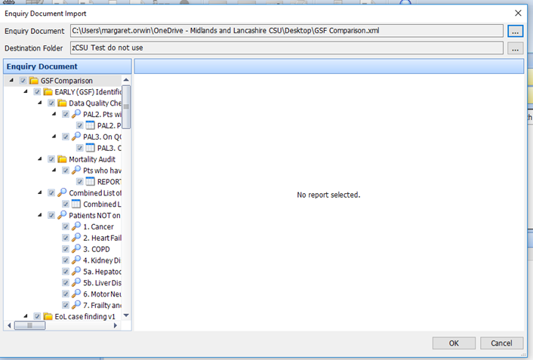

The searches will now be in your system and ready to run. Click OK

Running searches in EMIS
You need to run the searches to obtain the search results. You can run a search immediately after you import.
Navigate to and select the required search you just downloaded EARLY Identification Tool v1.0. Click on the folder of the search. If you click on the name of the folder this will then run all the searches within the folder
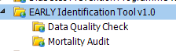
Click Run on the blue ribbon at the top of the page
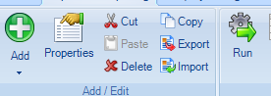
When viewing search results, ensure that the search has been run recently so that you are working with the latest results.

You can view the search results by individual searches or looking at the combined list of patients to be reviewed report
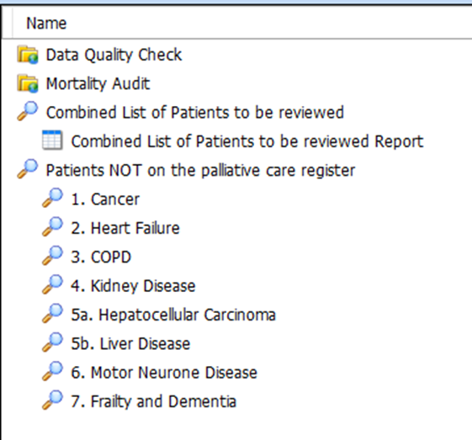

To view click once on the required report
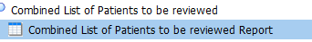
Select View Results on the ribbon.
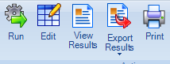
Note: The Export Results ribbon option is designed for exporting searches. It only allows you to export the report details, not the data. For this reason, you need to view a report before you can export it.
You can view the report on EMIS or you can export the results
On the Report Viewer ribbon, select Export.
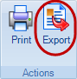

On the Export Report screen, choose from the following options:
Select a report format:
    - Excel
    - CSV
    - HTML
    - PDF
Tick the Exclude report header option, if you want to exclude the report header.
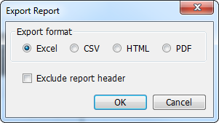
Click OK to export your report.
On the Save As screen, navigate to the folder you want to save your file in, and then click Save.
The data is saved in your chosen format

To view a Patient list and not a report:
Click on Combined list of patients to be reviewed
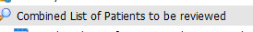
Navigate to the tabs at the bottom and choose population included
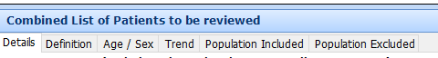
This will give you a list of all the patients from each search

Data Quality Folder:
Within the data quality folder there are 2 searches with reports.
PAL2. This gives you the patients that have been seen by Palliative Care Service in L2m but are not on your QOF Palliative care register
PAL3. This gives you patents on the QOF register but they have no GSF stage recorded

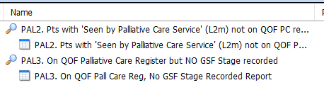
The Data Quality searches are there to help you identify patients that may have miscoding or may have something missing on their record.
Mortality Audit:
This search looks at patients who have died in the last 12 months.
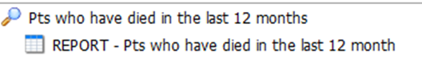
This search can help the practice to review those patients who have died over the last 12 months. Viewing the report indicates if they were already on the palliative care register, had an EPaCCS record, their preferred place of care/death recorded and carer/next of kin details.

Warning: Be aware of Information Governance standards before sharing files.
This guide has been written by the Data Quality Team Lancashire to help practices understand the tools created to assist with the EARLY Identification Tool v1.0. If you believe items are inaccurate or something is missing from the content, please contact your data quality contact within your area.

